**BlueWater LTD**

**Online Payment Application (OPA)**

**Project Management Plan**



Ibrahim Lawal

Liam Nilan

Ashar Zafri

Tony Leonard

[**Cover Page**](file:///C:\Users\tonyl\Downloads\Sample%20Project%20Plan%20Document%202021.docx#_Toc372720387)

[Table of Contents](file:///C:\\Users\\tonyl\\Downloads\\Sample%20Project%20Plan%20Document%202021.docx" \l "_Toc372720388) 2

**Section 1: Executive Summary**

[Executive Summary](file:///C:\Users\tonyl\Downloads\Sample%20Project%20Plan%20Document%202021.docx#_Toc372720388) 5

[**Section 2: Introduction**](file:///C:\Users\tonyl\Downloads\Sample%20Project%20Plan%20Document%202021.docx#_Toc372720398)

[2.1 What is an Online Payment Application?](file:///C:\Users\tonyl\Downloads\Sample%20Project%20Plan%20Document%202021.docx#_Toc372720399) 6

[2.2 Project Phases](file:///C:\Users\tonyl\Downloads\Sample%20Project%20Plan%20Document%202021.docx#_Toc372720400) 6

[2.2.1 Initiation Phase](file:///C:\Users\tonyl\Downloads\Sample%20Project%20Plan%20Document%202021.docx#_Toc372720418) 6

[2.2.2 Planning Phase](file:///C:\Users\tonyl\Downloads\Sample%20Project%20Plan%20Document%202021.docx#_Toc372720418) 6

[2.2.3 Execution Phase](file:///C:\Users\tonyl\Downloads\Sample%20Project%20Plan%20Document%202021.docx#_Toc372720418) 7

[2.2.1 Project Closure Phase](file:///C:\Users\tonyl\Downloads\Sample%20Project%20Plan%20Document%202021.docx#_Toc372720418) 7

**Section 3. Initiation Phase**

[3.1.1. Critical Assumptions and Constraints](file:///C:\Users\tonyl\Downloads\Sample%20Project%20Plan%20Document%202021.docx#_Toc372720406) 8

[3.1.2 Preliminary Requirements](file:///C:\Users\tonyl\Downloads\Sample%20Project%20Plan%20Document%202021.docx#_Toc372720409) 9

[3.1.3 Potential Risks](file:///C:\Users\tonyl\Downloads\Sample%20Project%20Plan%20Document%202021.docx#_Toc372720410) 9

[3.1.4 Project Charter](file:///C:\Users\tonyl\Downloads\Sample%20Project%20Plan%20Document%202021.docx#_Toc372720412) 10

**Section 4: Planning Phase**

[4.1 Project Work Breakdown Structure](file:///C:\Users\tonyl\Downloads\Sample%20Project%20Plan%20Document%202021.docx#_Toc372720415) 12

[4.2 Scope Verification Plan](file:///C:\Users\tonyl\Downloads\Sample%20Project%20Plan%20Document%202021.docx#_Toc372720417) 12

[4.2.1 Scope Introduction](file:///C:\\Users\\tonyl\\Downloads\\Sample%20Project%20Plan%20Document%202021.docx" \l "_Toc372720418) 14

[4.2.2 Project Characteristics and Requirements:](file:///C:\\Users\\tonyl\\Downloads\\Sample%20Project%20Plan%20Document%202021.docx" \l "_Toc372720419) 14

[4.2.3 Summary of Project Deliverables](file:///C:\Users\tonyl\Downloads\Sample%20Project%20Plan%20Document%202021.docx#_Toc372720420) 14

[4.3 Project Schedule](file:///C:\Users\tonyl\Downloads\Sample%20Project%20Plan%20Document%202021.docx#_Toc372720426) 15

[**Section 5: Analysis and Design Phase**](file:///C:\Users\tonyl\Downloads\Sample%20Project%20Plan%20Document%202021.docx#_Toc372720430)

[5.1 Context and Level 1 Diagram](file:///C:\Users\tonyl\Downloads\Sample%20Project%20Plan%20Document%202021.docx#_Toc372720415) 16

[5.2 Use Case](file:///C:\Users\tonyl\Downloads\Sample%20Project%20Plan%20Document%202021.docx#_Toc372720415) 17

[5.3 Activity Diagram](file:///C:\Users\tonyl\Downloads\Sample%20Project%20Plan%20Document%202021.docx#_Toc372720415) 17

[5.4 Sequence Diagram](file:///C:\Users\tonyl\Downloads\Sample%20Project%20Plan%20Document%202021.docx#_Toc372720415) 18

[5.5 State Diagram](file:///C:\Users\tonyl\Downloads\Sample%20Project%20Plan%20Document%202021.docx#_Toc372720415) 18

[5.6 Class Diagram](file:///C:\Users\tonyl\Downloads\Sample%20Project%20Plan%20Document%202021.docx#_Toc372720415) 19

[**Section 6: Execution, Monitoring and Control Phase**](file:///C:\Users\tonyl\Downloads\Sample%20Project%20Plan%20Document%202021.docx#_Toc372720432)

[6.1.1 Introduction - Risk Log](file:///C:\Users\tonyl\Downloads\Sample%20Project%20Plan%20Document%202021.docx#_Toc372720433) 20

[6.1.2 Planning Risk Management](file:///C:\Users\tonyl\Downloads\Sample%20Project%20Plan%20Document%202021.docx#_Toc372720434) 20

[6.1.3 Identifying Risks](file:///C:\Users\tonyl\Downloads\Sample%20Project%20Plan%20Document%202021.docx#_Toc372720435) 21

[6.2 Change Control Management Plan](file:///C:\Users\tonyl\Downloads\Sample%20Project%20Plan%20Document%202021.docx#_Toc372720452) 22

[**APPENDIX LIST**](file:///C:\Users\tonyl\Downloads\Sample%20Project%20Plan%20Document%202021.docx#_Toc372720460)

APPENDIX 1 - List of the Functional and Non-Functional Requirements: ...................................... 23

APPENDIX 2 - Work Breakdown Structure(WBS)….......................................................................... 23

[APPENDIX 3 – Record of Meetings:](file:///C:\Users\tonyl\Downloads\Sample%20Project%20Plan%20Document%202021.docx#_Toc372720463) 24

[APPENDIX 4 - Description of tools used for communications & collaboration…………](file:///C:\Users\tonyl\Downloads\Sample%20Project%20Plan%20Document%202021.docx#_Toc372720464)….................. 24

[APPENDIX 5 - Gantt Chart:](file:///C:\Users\tonyl\Downloads\Sample%20Project%20Plan%20Document%202021.docx#_Toc372720465) 24

[APPENDIX 6 - List of Software Used:](file:///C:\Users\tonyl\Downloads\Sample%20Project%20Plan%20Document%202021.docx#_Toc372720466) 24

[APPENDIX 7 - Abbreviations:](file:///C:\Users\tonyl\Downloads\Sample%20Project%20Plan%20Document%202021.docx#_Toc372720473) 25

[APPENDIX 8 - References:](file:///C:\Users\tonyl\Downloads\Sample%20Project%20Plan%20Document%202021.docx#_Toc372720474) 25

**Section 1: Executive Summary**

BlueWater LTD is a Galway base provider of water filtration products and services. They are renowned across the country for their high-quality products. Their systems are the number one choice in water filtration nationwide.

BlueWater currently uses an outdated and inefficient system for product and service orders. Customers must call the company hotline and request the product or service over the phone. The sales representative must enter the customer data manually. The sales representative follows up the sale by manually posting the customer out a document asking them to sign up to a monthly direct debit package. Customers who do not wish to receive any contact via post can alternatively download a PDF monthly direct debit form which is located on the company website. All forms signed by the customer must be returned to Bluewater by post. When the forms are all signed correctly the representative enters this data into the company database.

BlueWater have tasked us to replace this system to be a modern online payment application system or “OPA”. The proposed system will be as modern and responsive as the market leaders and will attract a wider variety of customers to the website. The system will have two primary functions. One side will act as a store front for customer who can browse and purchase products by credit card or PayPal. The money will be transferred to the BlueWater bank account. The second function will allow BlueWater to add, update or remove products from their online catalogue. The primary goal of this project is to replace and streamline the outdated system BlueWater previously used and cut out errors caused by implementing a digital solution.

Our estimates show that by implementing this new OPA system our clients' profits will increase by 10% over the next 18 months. This will be achieved by an increase in customers and a reduction of staff who were needed to run the previous system.

Our report breaks down the implementation of this system into four main phases. These are the initiation phase, planning phase, execution phase and closing phase.

**Section 2. Introduction**

2.1 What is an Online Payment Application?

An Online Payment Application or “OPA” is a service provided by an online website or online application which allows customers to pay for products, services, or invoices with ease. An OPA can be accessed by any device at any time given that the website or application is operating correctly. Some websites allow you to use the service without logging in,(as a guest) but the majority require you to register before you can use the OPA. A proper OPA should be secure, fast, and reliable as customers are trusting these websites and applications with their payment credentials and don’t want a reason to regret inputting their information into it.

When it comes to Bluewater the OPA is a new service for the company. Their method of collecting and processing customer information and payments was very outdated and cumbersome in the past. Their previous method required a lot of manual processing techniques which took a long time. Implementing an OPA into their company should see a decrease in processing times, which means customers will receive their products and services within a short time frame which helps with customer satisfaction. This in turn should boost sales for Bluewater and thus provide a higher yield overall.

2.2 Project Phases

The Bluewater online payment application is a large project and like any big project it requires us to break it down into separate phases. These phases include the Initiation phase, the Planning phase, the Execution phase and finally the Project Closure phase. All these phases play a vital role a project and doing them correctly will in turn provide us with a successful project.

2.2.1 Initiation Phase

This phase focuses on the feasibility of the project. The needs of the client are broken down by the project team into factors that could affect the project. The first thing that is discussed is the preliminary requirements of the project. After that, constraints are discussed as they are needed for setting deadlines. Risks are then evaluated so the team can best plan for them before the project starts. A project charter is then complied and signed by all team members and stakeholders.

2.2.2 Planning Phase

Planning phase will start once the project is approved by management. Workload will be divided into smaller and more manageable tasks assigned to teams. Timelines will be followed using Gantt chart. This helps team to complete tasks and a brief analysis of risk, scope will be done to provide a new Online Payment Application (OPA) system for BlueWater LTD.

2.2.3 Execution Phase

This phase describes the Risk Log and shows how risks are logged and managed by the project team. It describes how the team plan risk management and identify said risks, it also includes details of the change control management plan.

This phase presents a structured way to advance towards the execution, monitoring, planning, and control phase of the project activities at an operational level.

2.2.4 Project Closure Phase

This phase is initiated once all the work outlined in the execution phase is completed. All the finalizing work such as documentation, contracts and deliverables are signed and completed. A review of the quality of work the team did during the project is conducted. This also includes the teams communication with each other and the client. Other parts of the project are reviewed such as scope, budget and time management. Finally, a project completion document is signed.

**Section 3. Initiation Phase**

3.1.1 Critical Assumptions and Constraints.

**Critical Assumptions:**

Critical assumption planning is the compiling of basic assumptions about the main structure a project before starting it. This can be used to predict any major uncertainties in a project and how to mitigate them.

These are the assumptions we have made on the BlueWater OPA project:

Ordering is not limited to opening hours:

By using an OPA system a customer can order anytime day or night. This would remove the need for a sales representative to be present at the phone. The customer details will be handled electronically by the new system instead.

Increase customer satisfaction:

We assume there will be greater customer satisfaction because they will be able to enter their own details correctly without the sales representative mis hearing them on the phone. They will be able to receive the monthly direct debit package form via email instantly. There is no guarantee this will lead to increased sign-up.

Profits will increase by 10%:

Due to the reduction in staffing costs, postage costs and the potential increase in customers, after implementing this system, BlueWater LTD could see their annual profits increase by 10%. The streamlined system may improve customer engagement and lead to more direct debit sign-ups.

**Constraints:**

Scope:

BlueWater LTD outlined clear and achievable goals for this OPA system project. This scope has been agreed and will be followed. If the client wishes to have any changes made, they can be brought up and discussed in stakeholder update meetings. In these meetings we can discuss additions or changes and document them. We can also identify what is to be excluded from the project to prevent scope creep.

Cost:

BlueWater LTD have not made the budget for this project clear. Due to this we will have to research the cost of similar OPA system project and how to best provide a quality system for a fair price. We will need to manage scope creep and the project schedule to keep the costs down.

Time:

The client did not set any time constraints for the project so like the cost researching existing OPA projects will be needed. We can implement time management into the project using project management software such as JIRA or Microsoft project to set reasonable goals for when to finish parts of the project.

3.1.2 Preliminary Requirements.

This section of the project will outline the requirements laid out by the client. It will cover the functionality for both the customer and the requirements requested BlueWater management. This will only be a high-level overview of this project's requirements. Later in the document these requirements will be expanded upon and we will display our solutions.

Login System

The login system for customers is one of the most vital parts of this new OPA system. New and existing customers will be able to search and view products. When they select one to buy, they will be prompted to sign in or sign up. When signing up customers must enter their full name, email, address, contact details, password, and payment details. They will be then added to the database. There will also be a check box for if they want to receive promotional emails. Existing customers will only need to enter their email and password and will have access to the items in their cart that are saved to their account.

Product Catalog

As mentioned, the website will have a catalog of products that BlueWater provides. A registered user may select an item and add it to their cart. Each product on this list must be editable by BlueWater staff and items should be easy to remove and add. It must also be consistent in style and take up equal space on the products page.

Ordering and Payments

On the cart page there should be a button for checkout. This should bring the customer to a checkout page where all the items they selected are shown alongside their price. The total will be at the bottom with two buttons. Pay by card and PayPal. If pay by card is selected the customer should enter the CVV number of the card they attached to their profile. The payment is then processed and the money is sent to BlueWater LTDs bank account. The order is then confirmed by email and sent to the customer's address.

3.1.3 Potential Risks.

When starting a project such as this it is important to try foresee any potential risks before starting. This is a good way to minimize future cost overruns and delays. This list will be brought to the client so the team can be transparent with all aspects of the project. The list is as follows:

Staff Layoffs

Due to the fact this system will lead to the direct reduction of Bluewater's workforce there is a likely chance that the staff will not be pleased with the new system. It would be best for BlueWater to make their intentions clear early in order to allow the redundant staff to seek alternative employment over the 18 months.

GDPR risk

As part of the requirements user data is store on the systems database. This includes full names, addresses, emails, contact details and passwords. If there was to be a data breach it could be catastrophic for Bluewater's reputation and there could be potential for a fine up to 20 million or 4% of the company’s annual revenue [1]. To stay ahead of this the OPA system will need regular security updates, the database will need to be encrypted and customers must be able to request to delete their data [2].

Milestone deadlines missed

This risk is one of the more difficult ones to mitigate as any member of the team can go off sick. Other factors that could cause the deadlines to be missed are scope creep and budget disputes. The best way we can manage these is to have open communication with the client and to reschedule any upcoming deadline in a way that is both fair to the developers and satisfactory to the client.

3.1.4 Project Charter [3]

|  |  |  |  |  |
| --- | --- | --- | --- | --- |
| Project Charter | | | | |
| Project Name | BlueWater OPA | | | |
| Project Description | Create an online shop website with payment for BlueWater LTD to replace their existing system. | | | |
| Project objectives | * Make the website easy to edit the product catalog. * Have a customer login system. Allow registered users to buy. * Allow Pay by card or PayPal. * Expand reach to new market of customers. | | | |
| Project is considered successful when: | * Profits for Bluewater have increased by 10%. * Direct debit sign-ups increases to 1000 customers a year. * Time between orders and shipping cut dramatically. * Increase in new customers. | | | |
| Project Participants | Developers: Ibrahim Lawal, Liam Nilan, Ashar Zafri, Tony Leonard  Client(s): BlueWater LTD Management | | | |
| Resources | Server Room, PayPal merchant account, Salary for developers | | | |
| Milestones | Goal | Due: | | Deadline: |
| 1. Build Backend for the OPA 2. Build Frontend and connect it to the backend. 3. Implementation of payment system. | 20/12/21    10/1/22      31/1/22 | | 24/12/21    24/1/22      14/2/22 |
| Risks | 1. Staff Layoffs 2. Milestones submitted past set date. 3. GDPR at risk | | | |
| Approval | Title | | Date | |
| CEO: Sebastian Bluewater  Signature:\_\_\_\_\_\_\_\_\_\_\_\_    Project Manager: Lí Ban  Signature:\_\_\_\_\_\_\_\_\_\_\_\_    Head of Sales: Israel Hands  Signature:\_\_\_\_\_\_\_\_\_\_\_\_ | | 1/11/21 | |
|  |  |  |  |  |

**Section 4: Planning Phase**

[4.1 Project Work Breakdown Structure](file:///C:/Users/tonyl/Downloads/Sample%20Project%20Plan%20Document%202021.docx#_Toc372720415)

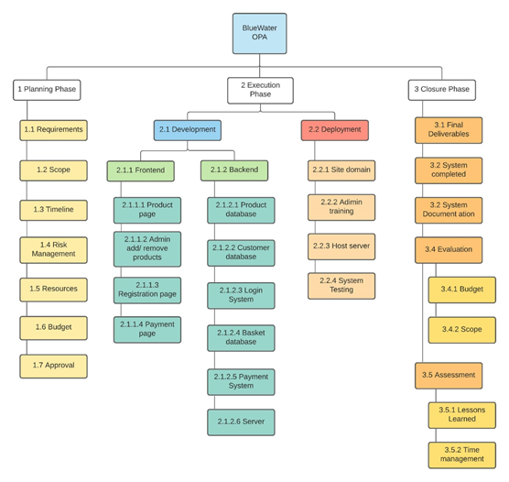

[4.2 Scope Verification Plan](file:///C:/Users/tonyl/Downloads/Sample%20Project%20Plan%20Document%202021.docx#_Toc372720417)

The Scope verification will take place at the completion of every phase of project and is the formal technique of verifying the project scope with the stakeholders. This includes analyzing the products and consequences in opposition to the original set out plan to ensure the work is being completed within the timeline. If there are any delays in work, within the set timelines. Different techniques will be used to ensure that tasks in each phase will be completed within the timelines to stay away from any delays.

|  |  |  |
| --- | --- | --- |
| **Roles and responsibilities of key project stakeholders [5]** | | |
| **Project Role** | **Responsibilities** | **Comments** |
| **Executive Sponsor** | A person or group who provides resources and support for the project and is accountable for enabling success. | Help eliminate barriers.  Approves final plan. |
| **Project Lead** | Main person accountable for the success of the project. Work plan, resources allocation, risk management, scope change control, milestones monitoring, and communicates project status to all stakeholders. | Authority to manage people, conflict, risks and issues. |
| **Project Coordinator** | Coordinates project effort from start to end. Applies project management methodologies and tools to ensure projects deliver the expected results within scope, time, and budget. | Limited authority over resources. Escalates risks, issues, and people management matters to the Project Lead. |
| **Functional / Technical Lead** | SME responsible for leading the effort of a functional or technical area (e.g. Networking, etc.) | Authority to assign work and resources. |
| **Team Member**  **(Subject Matter Experts - SMEs)** | Staff members who exhibit high level of expertise in a specialized job, task, or skill. SMEs are responsible for performing specific tasks of the project to achieve its objectives (e.g. Sysadmin, Web Developer, Business Analyst, etc.). They help defining requirements and are often heavily involved in testing and training. | They report progress of their work, and related issues or risks to the Project Lead and Project Coordinator. |

[4.2.1 Scope Introduction](file:///C:/Users/tonyl/Downloads/Sample%20Project%20Plan%20Document%202021.docx#_Toc372720418)

In this project we will build a new Online Payment Application (OPA) system for BlueWater LTD. The new OPA system will streamline and accelerate the current ordering process. It will penetrate new consumer markets and improve customer service. Additionally, it will reduce human error in relation to manual ordering and reduce delays in the billing process. Following the implementation of the OPA system sales handler employees will be reduced by 50% over 18 months and there will be an increase profits by 10% in 18 months.

The OPA should have two functions:

1. It provides a facility for a business to add a product or service.
2. It also provides a method for customers to view the product/service, create an account and enter their payment details on a secure payment page.

Moreover, payments will be done safely online from the customer using credit card to BlueWater LDT to avoid unnecessary delays and Human errors.  
(All listed development can be found in diagram 1)  
This OPA system is expected to help Bluewater to obtain a 10% increase of revenue annually through the implement of the OPA system. The Project Team forecasts that based on direct debit sign up by 1,000 customers at €120 a year, the organization will yield a revenue stream of €120,000.  
  
 [4.2.2 Project Characteristics and Requirements:](file:///C:/Users/tonyl/Downloads/Sample%20Project%20Plan%20Document%202021.docx#_Toc372720419)    
  
The following characteristics must be met in order to design and complete a quality project. Firstly, a good leadership with clear and achievable goals recognized by each team member. Leadership will keep track of all deliveries in project meet timelines. A good communication chain also to help over the barriers together as a team. All members should understand work breakdown structure and follow the timeline to complete the task to avoid any delays.   
  
   
[4.2.3 Summary of Project Deliverables](file:///C:/Users/tonyl/Downloads/Sample%20Project%20Plan%20Document%202021.docx#_Toc372720420)    
  
The outcome of this project is to have a function Online payment application. Tasks have to be completed within the time frame. This can be made possible by creating a Gantt chart and breaking tasks into more manageable tasks.  
  
 According to our Gantt chart the first task will be to research and plan. This will allow us to set clear goals and define our focus to have a function Online payment application. Moreover, in this we will do a brief analysis of all the risks involved, plan timelines from start to end and discuss other factors to allow us to set the direction for the team.  
  
Furthermore, after analyzing and approving the planning we will move to development phase. In this we will design the frontend and backend. We will convert design prototyped into working system. Task included in this are product page, connecting to database and connecting to servers.   
Lastly, staff and company will be trained, and all the useful information will be provided. In the Closure phase complete system will be evaluated to monitor the success of this project by looking at factors such as budget to finalize and prove the project.

[4.3 Project Schedule](file:///C:/Users/tonyl/Downloads/Sample%20Project%20Plan%20Document%202021.docx#_Toc372720426)The following is the Gantt chart is for the BlueWater project due to finish within 5 months. Setting timelines for each task in this project.

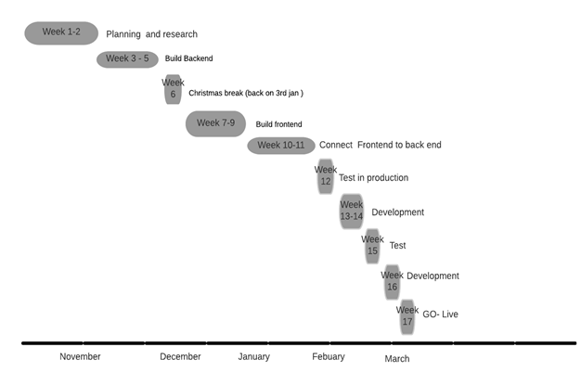

**Section 5: Analysis and Design Phase:**

5.1 Context and Level 1 Diagram [4]: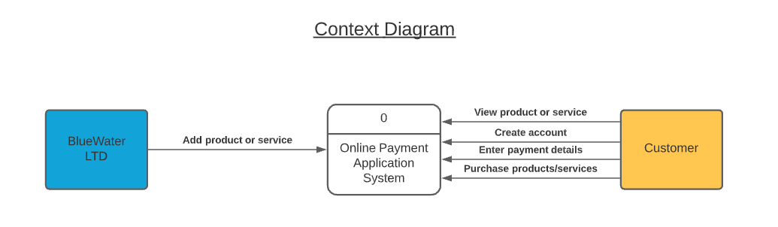

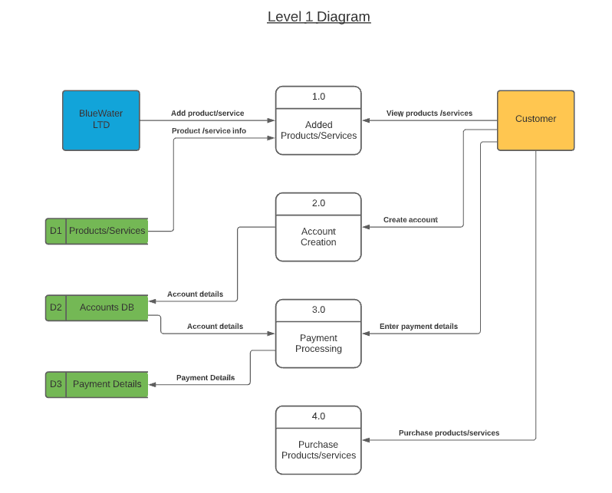

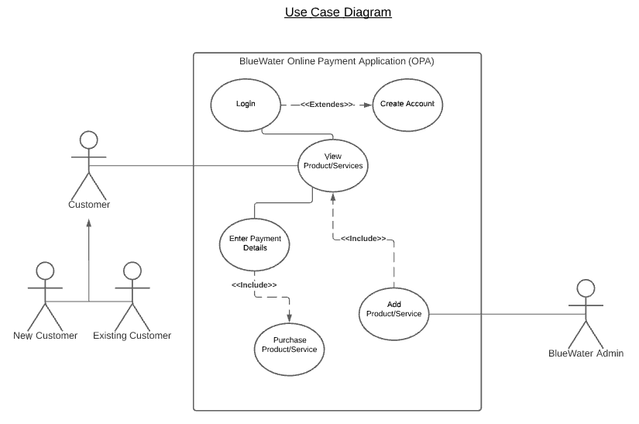5.2 Use Case Diagram [4]:

5.3 Activity Diagram [4]:

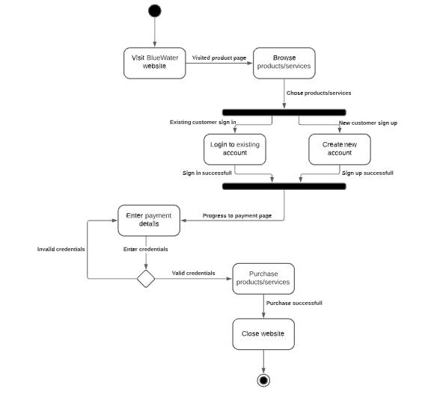

5.4 Sequence Diagram [4]:

5.5 State Diagram [4]:

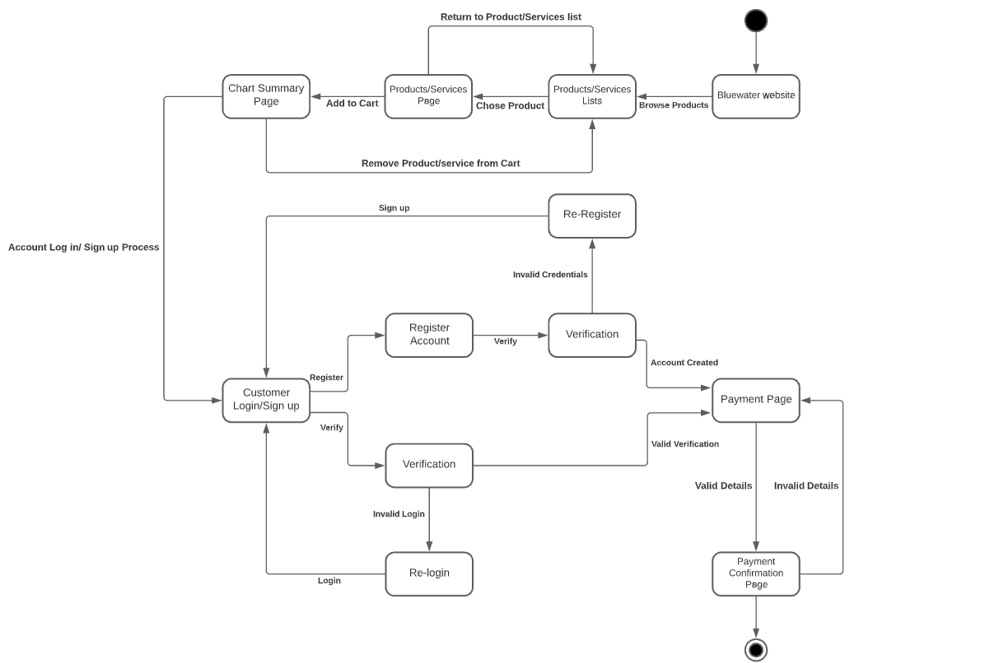

5.6 Class Diagram [4]:

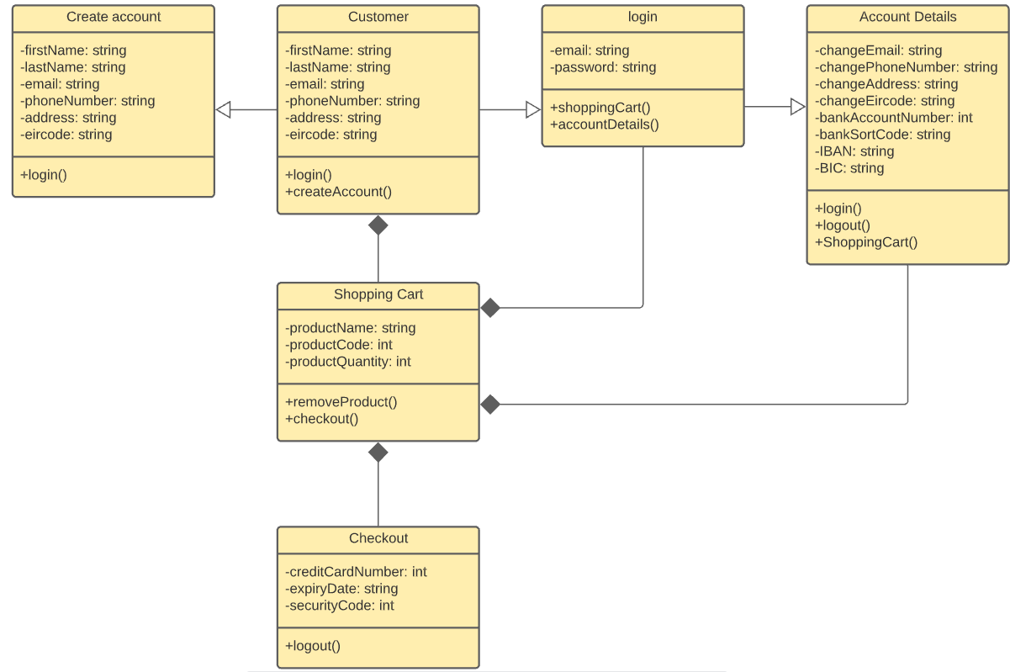

**Section 6: Execution, Monitoring and Control Phase:**

6.1.1 Introduction – Risk Log [6]:

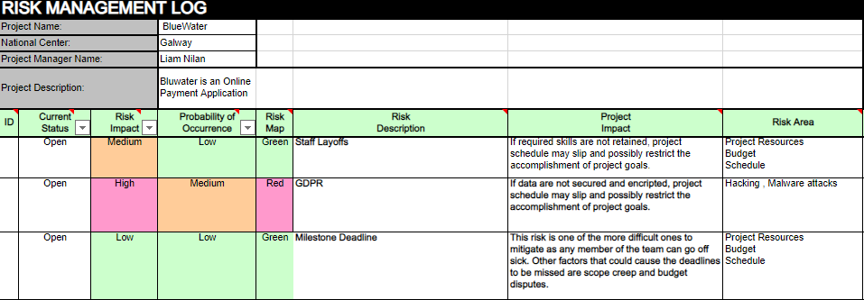

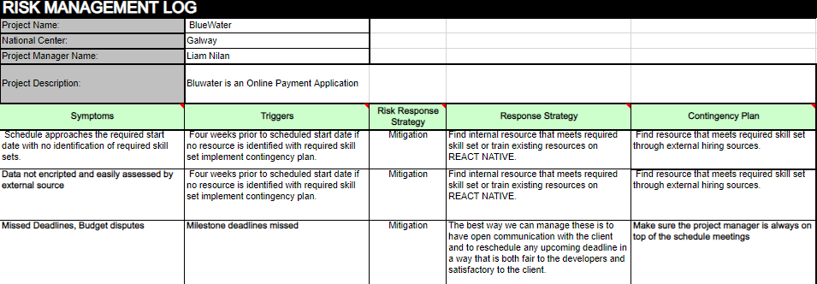

6.1.2 Planning Risk Management:

Every project has its risks. At the start of any project, it is essential to set up a system to identify the dangers of the project at the start. The main purpose of this procedure is to reduce the risk of diminishing or delaying the venture. A meeting with all the project contributors should be step one of the risk control system. Everyone in the meeting can bring up potential risks they anticipate might surface. Anybody related to the assignment should have the possibility to post a risk irrespective of the position they hold. This offers the team extra odds of figuring out all risks involved, even as additionally promoting lateral thinking, and reducing biased entries. Potential risk assessment should best be a standard at the start of the project, and all through the whole life cycle of the project. The risk log must continue to be an open file. The risks must then be recorded and filed for use of the team later. All risks must be blanketed inside the evaluation regardless who is susceptible.  
As soon as a risk is submitted it should be evaluated so that it will prioritize the impact it could have on the project. After assessing the effect, it could have on the project, the team should additionally check the possibility of the risk happening again. This permits the team to put in a threat assessment and remediation (TARA) document inside the chance log. When that is finished you need to determine the precise amount of assets the team ought to allocate toward handling the risks. Each risk will then be assigned an appropriate owner who will from that factor be liable for managing the risk.  
This procedure offers the team the opportunity to be proactive in responding to chance in preference to reactive. A proactive measure whilst working towards right chance management is to ensure there is the ideal mitigation strategy assigned to each risk. This reaction could be directed through the risk owner.

6.1.3 Identifying Risks:

Referencing the above paragraphs, the project beginnings is the most important stage to have all arrangements of schedules for project meetings, and objective forecast for potential risks that may arise. An additional measure may be put in place to further extract the idea of the team members, such as one on one interviews and peer reviewing each other’s submissions on the project and analyzing risks that may arise.

Looking into past projects of similar nature would be another avenue that could be used to identify risks. Creating a solid list of risks, all risks entries must be screened and evaluated by the team member assigned the responsibility of risk manager. This is to avoid filling the risk log with risks that are extremely unlikely to occur. This should be performed by an experienced team member.

If there are unusual and or unique aspects to the project that eventually bring out major risk, this risk must be correctly identified, it is necessary to investigate the type of risk by highlighting some of its key features. The initial characteristics that must be analyzed is the impact on the project. Key items must be taken into perspective in the arriving on a final verdict on the overall impact of the risks. Impacts on scope, time and cost are assessed to fully understand the severity of the risk. Each of these factors will then be assigned a grade out of one hundred, with one hundred indicating maximum impact and zero indicating the minimum impact. Using that grade the team will determine whether the impact will be low, medium, or high.

The probability of the risk must then be evaluated. This is not an exact science, but an educated estimation should be formed as it is a good indicator as to how urgent the need to formulate a response plan will be.

6.2 Change Control Management Plan:

Change control management plan is the process used to carry out all the phases of initiation, recording, assesses, approvals, and resolving changes made to the project. The Bluewater team deem it necessary to implement the change control management plan, to ensure that a proper procedure is in place to check and balance all eventualities before change is affected. The changes requests will undergo the following procedures:

1. Change Request Submission:

This process involves submitting a request for a change to the project after the change requester has done all his/her analysis, evaluation and identifies the there is a need to change an aspect to the project. A change request form is completed and submitted to the project manager. This form highlights the reasons, benefits, costs, impacts, documentation, and approvals for the change.

1. Change Request Analysis:

An analysis meeting is headed by the project manager to look at alternative ways that the project could achieve the intended change. Team members in charge of the work packages determine the budget, the time required, and the professionals required. As these activities change, the budget, time required, and professionals required may change as well, so it is discussed whether the project can accommodate such changes. When there is gap in the schedule, it is necessary to redistribute workers, change the schedule, and allow a specific activity to take longer because it does not affect the project's overall duration. Getting those members of the project team who need to execute the modification as soon as possible. Where there is a surplus of time, it is critical to expand gap. A particular quantity of information is required from predecessor tasks across the work package, yet that task is started with incomplete information due to the project manager's guidance.

1. Change Request Approval:

To validate a change request approval, there is a deliberation meeting between the project manager, development manager, lead programmer and the client. This meeting will be a small group in other for all communiques to be well received and addressed operations details as well.

1. Change request Implementation:

If the change request has been approved by the change control board, the status of the change request is changed to “Approved”. This is then displayed on the log, and work can begin.

[**APPENDIX LIST**](file:///C:\Users\tonyl\Downloads\Sample%20Project%20Plan%20Document%202021.docx#_Toc372720460)

Appendix 1 – List of the Functional and Non-Functional Requirements:

***Functional:***

* Account creation and login for customers
* Secure payment and proper credit card/debit card regulation
* Display products and services and have a function to add and remove products/services

***Non-Functional:***

* Staff hiring process and training and safety regulation
* Proper Server and office regulation, proper Covid-19 site regulations and social distancing
* Application optimization, security and performance with regular updates and testing
* Proper HR department with online workplace functionality

Appendix 2 – Work Breakdown Structure (WBS) :

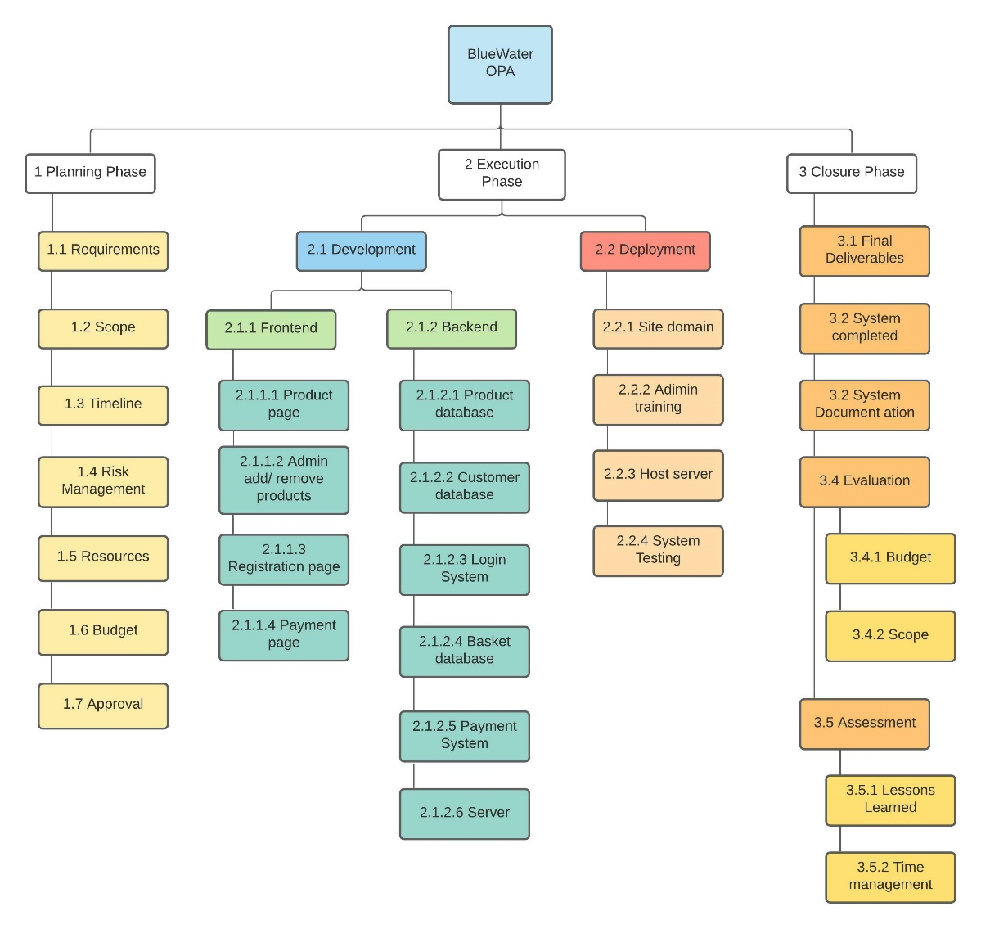

Appendix 3 – Record of Meetings:

**5th November from 11:00 – 11:30:** First team meeting where the team members were allocated their work.

**12th November from 11:00 – 11:30:** Second team meeting where the team members peer reviewed each other’s work, created a collaborative document, and entered all their reviewed work.

**19th November from 11:00 – 11:30:** Third team meeting where the team members again peer reviewed their work and entered their reviewed work into the collaborative document.

**26th November from 11:00 – 11:30:** In the fourth team meeting we split the remaining work amongst the group.

**3rd December from 11:00 – 11:30:** In the fifth team meeting we peer reviewed the work that was completed and started to finalize the appendix section.

**10th December from 11:00 – 11:30:** In the last meeting we started on the executive summary and tried to finalize all the other sections.

Appendix 4 - Description of tools used to for communications & collaboration:

Tools used:

The team exclusively used Microsoft Teams for communications, file sharing and attending meetings.

Appendix 5 – Gantt Chart: 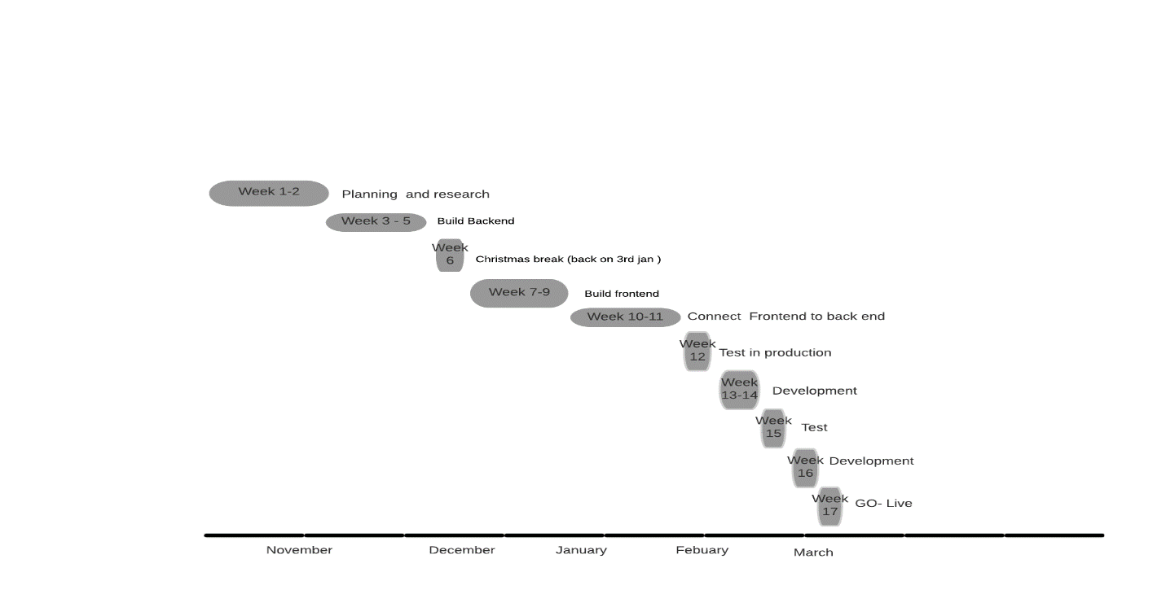

Appendix 6 – List of Software Used:

**Coding Languages used:** Java, JavaScript, CSS, HTML, React.

**Database Used:** MySQL Database.

**Miscellaneous:** Lucidchart diagram design tool.

Appendix 7 – Abbreviations:

**OPA: Online Payment Application**

**WBS: Work Breakdown Structure**

**TARA: Threat Assessment & Remediation Analysis**

**SME: Subject Matter Expert**

Appendix 8 – References:

[1] “What are the GPDR Fines”

<https://gdpr.eu/fines/>

[2] ”GDPR checklist for data controllers”

<https://gdpr.eu/checklist/>

[3] “How To Write a Project Charter: Ultimate Guide”

<https://www.wrike.com/blog/project-charter-guide/#What-is-a-project-charter>

[4] Lucidchart design tool used for creating the UML diagrams and Gantt Charts used in this project:

[https://www.lucidchart.com/pages/](https://www.lucidchart.com/pages/landing?utm_source=google&utm_medium=cpc&utm_campaign=_chart_en_tier1_mixed_search_brand_exact_&km_CPC_CampaignId=1490375427&km_CPC_AdGroupID=55688909257&km_CPC_Keyword=lucidchart&km_CPC_MatchType=e&km_CPC_ExtensionID=&km_CPC_Network=g&km_CPC_AdPosition=&km_CPC_Creative=354596043016&km_CPC_TargetID=kwd-33511936169&km_CPC_Country=1007864&km_CPC_Device=c&km_CPC_placement=&km_CPC_target=&mkwid=sSyVrRTB8_pcrid_354596043016_pkw_lucidchart_pmt_e_pdv_c_slid__pgrid_55688909257_ptaid_kwd-33511936169_&gclid=CjwKCAiA4veMBhAMEiwAU4XRr6cUcpjZ8wzzJvmLjKYLCCoEJVaYM2RBti2EuvVdf-nqrmcF1pDrExoCf30QAvD_BwE)

[5] Roles and responsibilities of key project stakeholders:

<https://it.sonoma.edu/kb/pm/what-are-roles-and-responsibilities-key-stakeholders>

[6] Risk Management Log Template:

<https://dayungkayuu.blogspot.com/2021/05/project-management-risk-register.html>